#### 

#### TO SUPPLY LEFTOVER FOOD TO POOR

**Category :** Salesforce

**Skill Required:** Salesforce Developer

**Introduction**

Salesforce is a leading cloud-based Customer Relationship Management (CRM) platform that provides versatile tools for managing and optimizing customer relationships, sales processes, and customer service. For this project, aimed at helping supply leftover food to the poor, Salesforce serves as a comprehensive solution that can streamline processes and improve the efficiency of this charitable mission. This chapter will discuss Salesforce's core functions and how they support the goals of the project.

**Project Overview**

The **Food Distribution Project** in Salesforce is designed to streamline the process of collecting and distributing leftover food to those in need. The project uses Salesforce objects and automation tools to manage venues (where food is collected), drop-off points (where food is distributed), tasks (for managing food pickup and delivery), volunteers, and execution details for each distribution event. Key objects in the system include **Venue**, **Drop-Off Point**, **Task**, **Volunteer**, and **Execution Details**. Each object captures essential data, such as venue locations, volunteer assignments, and food distribution statistics, enabling efficient tracking and coordination of the distribution process

**Overview of salesforce:** Salesforce offers a wide array of functionalities that allow organizations to manage interactions and relationships with various stakeholders, including clients, volunteers, and donors. Key modules in Salesforce include:

* **Sales Cloud:** Enhances sales process efficiency through lead tracking and management tools, ensuring effective outreach and engagement.
* **Service Cloud:** Focuses on customer service, providing tools for case management and knowledge sharing that could support the logistics of food distribution.
* **Marketing Cloud:** Automates communication and engagement, including email campaigns and analytics, helping nonprofits reach out to donors and partners efficiently.

**Key features supporting the project**

For the “**Supply Leftover Food to the Poor**” project, Salesforce can enhance operations through:

* **Data Management:** Centralized storage of donor information, distribution points, and logistical data.
* **Real-Time Reporting and Analytics:** Allows for monitoring food supply levels, analysing distribution metrics, and generating reports to improve efficiency.
* **Mobile Accessibility:** Ensures volunteers and team members can update and access information on the go, a crucial feature for field operations in food distribution.

**Objective:**

This project aims to develop a salesforce based application designed to manage and streamline the distribution of leftover food to undeserved communities.The primary goal is to enhance the efficiency of food drop-offs,coordinate tasks,manage volunteers and generate insightful reports.

**Goals:**

* **Streamline Food Collection** – Enable donors to easily register and donate leftover food.
* **Centralize Data Management** – Use Salesforce to store and manage donor, volunteer, and recipient data.
* **Optimize Logistics** – Automate routes and volunteer assignments for efficient food delivery.
* **Track and Report** – Monitor donation flows and generate reports to improve operations.
* **Enhance Communication** – Keep donors and volunteers informed through updates and alerts.
* **Ensure Food Safety** – Maintain quality standards and train volunteers in food handling.
* **Plan for Expansion** – Build a scalable system to support future growth in different regions.
* **Raise Awareness** – Use marketing tools to engage the community and attract more support.

**Detailed Description of Implemented Features**

**Salesforce Developer Account Creation**

* To sign up for a salesforce account
* To login to your salesforce account
* Account activation

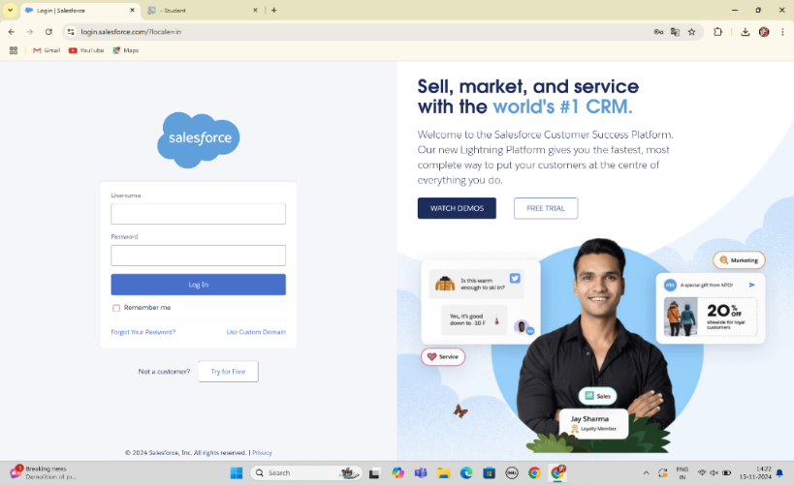

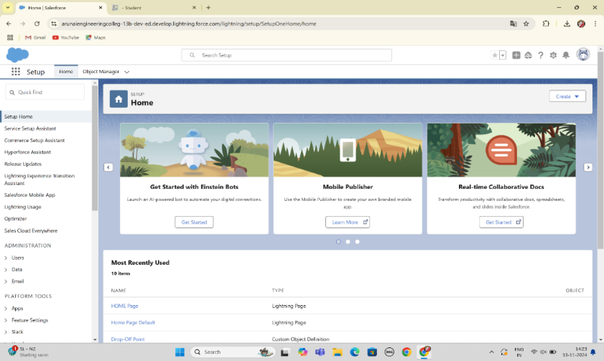

**Object Creation**

**Venue**:

Stores information about locations where leftover food is collected or stored before distribution, including details like address, contact person, and facility capacity.

**To create an object:**

From the setup page >> Click on Object Manager >> Click on Create >>Click on Custom Object.

* Enter the label name >> Venue
* Plural label name >> Venues
* Enter Record Name Label and Format
* Record Name >> Venue Name
* Data Type >> Text
* Click on Allow reports and Track Field History,Allow Activities.
* Allow search >> Save.

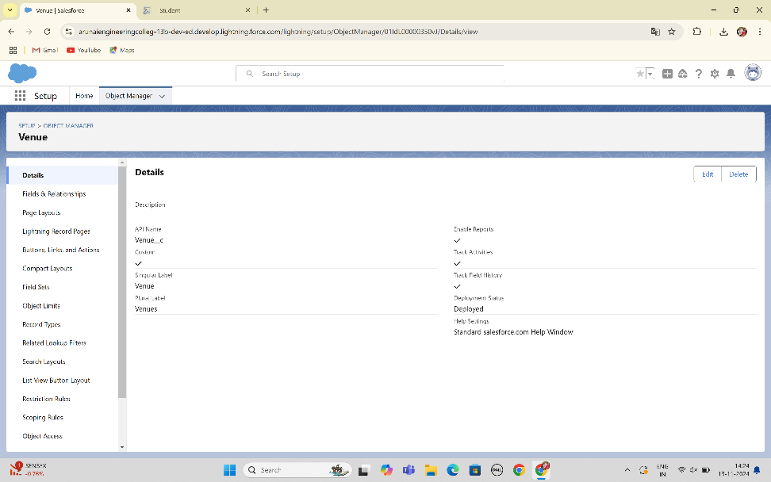

**Task**:

Logs specific tasks related to food collection, transportation, and distribution, assigned to volunteers or teams, ensuring accountability and tracking completion status.

**To create an object:**

From the setup page >> Click on Object Manager >> Click on Create >> Click on Custom Object.

1. Enter the label name>> Task
2. Plural label name>> Tasks
3. Enter Record Name Label and Format

* Record Name >> Task Name
* Data Type >> Text

1. Click on Allow reports and Track Field History,Allow Activities
2. Allow search >> Save.

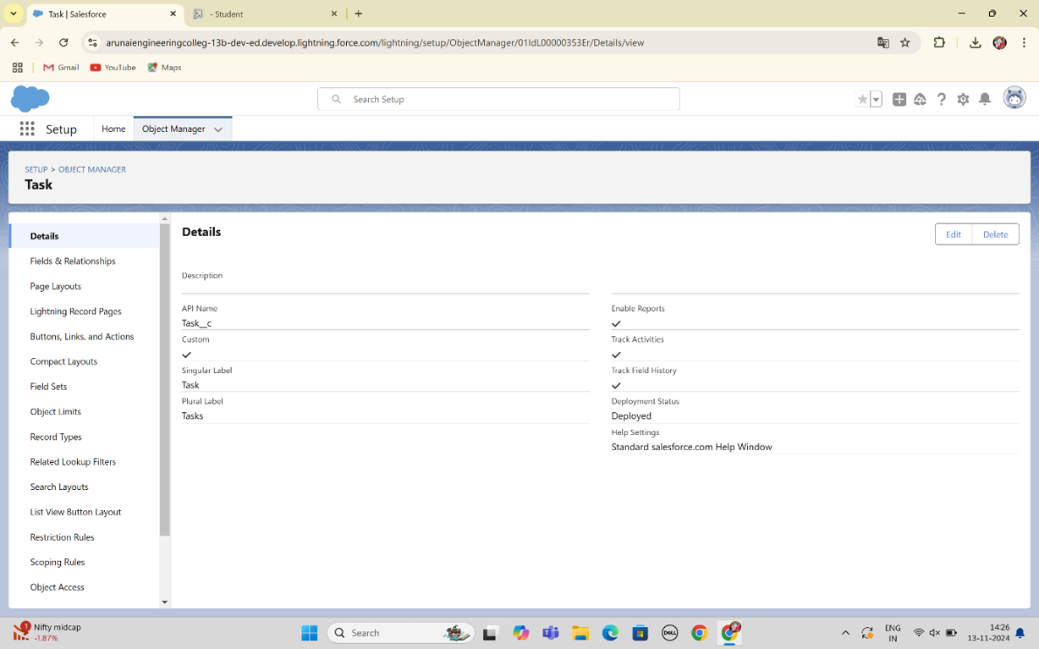

**Volunteer**:

Manages information about the volunteers, including availability, assigned roles, and contact details, to ensure effective communication and task delegation.

**To create an object:**

From the setup page >> Click on Object Manager>> Click on Create >> Click on Custom Object.

1. Enter the label name>> Volunteer
2. Plural label name>> Volunteers
3. Enter Record Name Label and Format

* Record Name >> Volunteer Name
* Data Type >> Text

1. Click on Allow reports and Track Field History, Allow Activities
2. Allow search >> Save

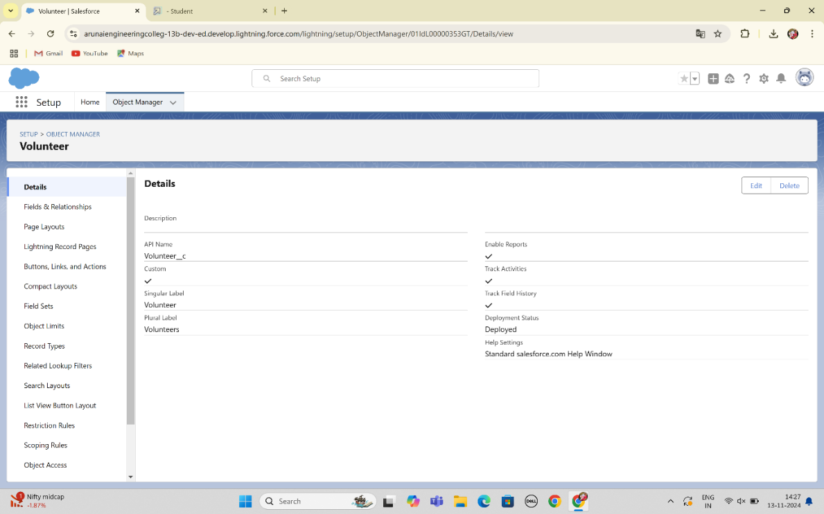

**Execution Details**:

Captures key information about each distribution event, including date, time, food type, and quantity, allowing for efficient planning and tracking of each distribution.

**To create an object:**

From the setup page >> Click on Object Manager >> Click on Create >> Click on Custom Object.

1. Enter the label name >> Execution Detail
2. Plural label name >> Execution Details
3. Enter Record Name Label and Format

* Record Name >> Execution Detail Name
* Data Type >> Text

1. Click on Allow reports and Track Field History, Allow Activities
2. Allow search >> Save.

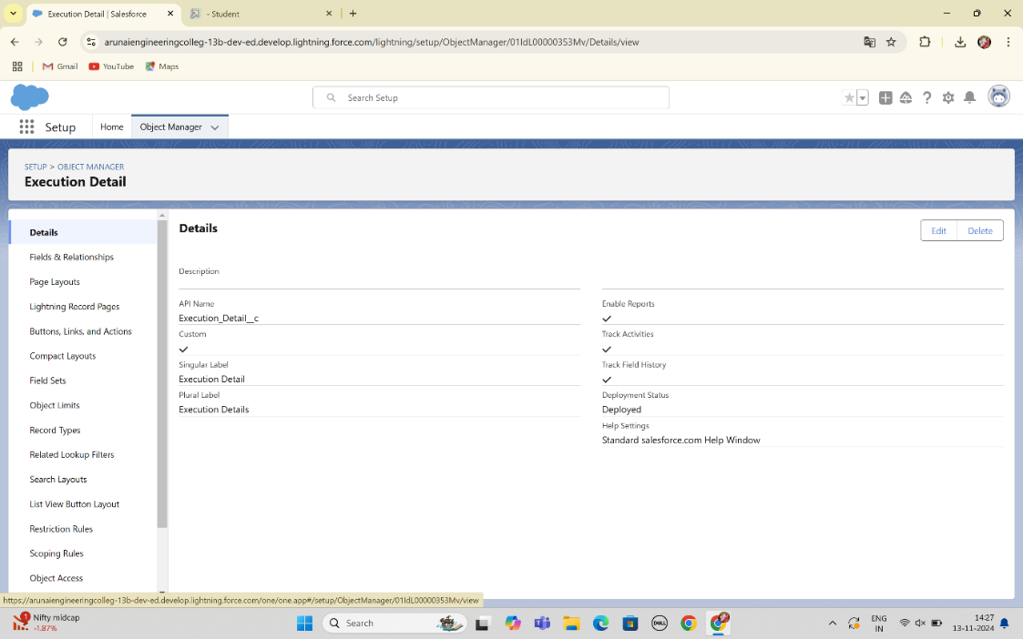

**Drop-Off Point**:

This object records information about specific locations where food donations are delivered for distribution.

**To create an object:**

From the setup page >> Click on Object Manager >> Click on Create >> Click on Custom Object.

1. Enter the label name >> Drop-Off Point
2. Plural label name>> Drop-Off Points
3. Enter Record Name Label and Format

* Record Name >> Drop-Off point Name
* Data Type >> Text

1. Click on Allow reports and Track Field History,Allow Activities
2. Allow search >> Save.

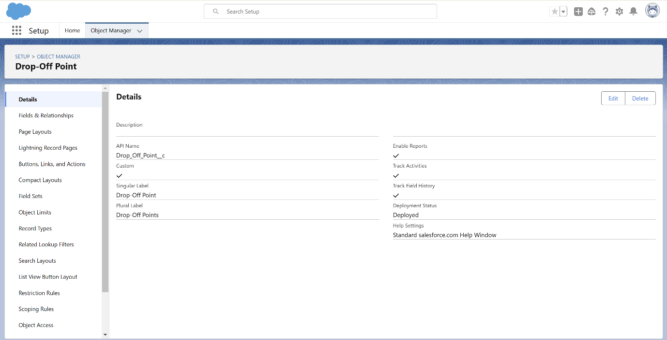

**Tabs**

In Salesforce, **tabs** are used to display and organize data for specific objects and functions within an application, making it easier to navigate and manage information. For your project, tabs will represent each key object—like Venue, Drop-Off Point, Execution Details, Volunteer, and Task—allowing users to quickly access, view, and update records.

**Types of tabs in salesforce**

* **Standard Object Tabs**: These display data for Salesforce’s built-in objects (e.g., Accounts, Contacts).
* **Custom Object Tabs**: These tabs display data for custom objects you've created, such as Venue, Drop-Off Point, Execution Details, Volunteer, and Task in your project.
* **Web Tabs**: These display an external website within Salesforce, useful if you need access to online tools directly in your app.
* **Visualforce Tabs**: These display data from a Visualforce page, allowing for customized UI and functionality beyond standard Salesforce capabilities.

**Creation of Custom tabs**

**To create a custom tab for each of your project’s objects, follow these steps:**

1. **Log in to Salesforce**: Ensure you’re logged in with administrator privileges.
2. **Access Setup**: Click the gear icon in the top-right corner and select “Setup.”
3. **Navigate to Tabs**: In the Quick Find box, type “Tabs” and select “Tabs” from the list.
4. **Create New Custom Object Tab**:
   * Click **New** next to "Custom Object Tabs."
   * Select the **Object** for the tab (e.g., Venue, Drop-Off Point, Execution Details, Volunteer, or Task).
   * Choose a **Tab Style** (an icon that represents the tab visually).
5. **Tab Label and Visibility**:
   * Enter a **Label** for the tab that will appear to users (e.g., "Venue" for the Venue object).
   * Select **Profiles** to determine which users will have access to this tab.
6. **Save and Organize**:
   * After saving, add the tab to the relevant **App** (e.g., your project’s custom app for food distribution) so it’s accessible within the application.
   * Use **App Manager** to arrange the tabs in your preferred order.

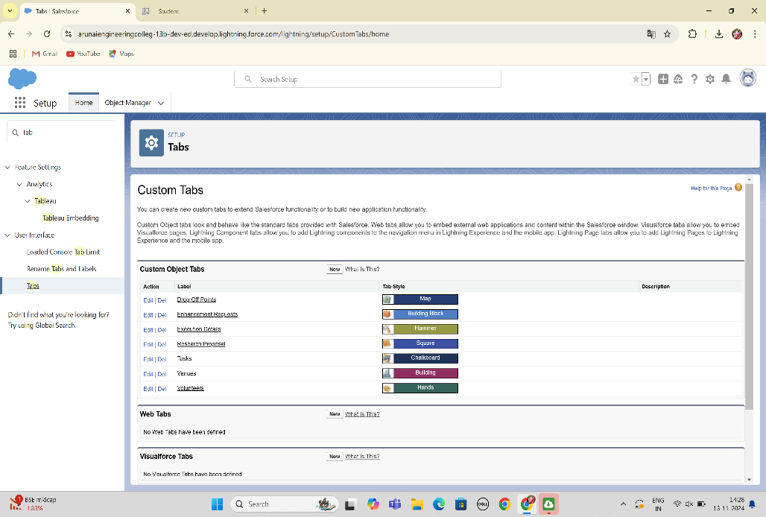

**Lightning apps**

Lightning Apps in Salesforce consist of a set of tabs and components that work together to enable specific functions. They have a name, logo, and a customizable set of tabs. There are two types of Salesforce applications:

1. **Standard Apps**: Default apps that come with Salesforce (e.g., Sales, Marketing, Chatter).
2. **Custom Apps**: Tailored apps with selected standard and custom tabs to meet specific needs.

**creation of lightning apps**

* **Access App Manager**:In Salesforce Setup, type "App Manager" in the Quick Find box and select it.
* **Create a New Lightning App**:Click on "New Lightning App" and enter the app name (e.g., "Food Supply Management").
* **Configure App Options**:Set the app's visibility, logo, branding, and any custom settings. Keep the default settings if not specified.
* **Utility Bar (Optional)**:Add tools like Notes or Chat to the app’s utility bar if needed.
* **Select Tabs**:Choose the objects and tabs you want to include, such as "Venue," "Drop-Off," "Execution Details," "Volunteer," and "Task" for a food distribution app.
* **Assign Profiles**:Specify which user profiles can access the app by moving relevant profiles (e.g., System Administrator) to "Selected Profiles."
* **Save and Launch**:Click "Save & Finish" to complete setup. Access the app through the App Launcher to verify that all tabs and settings appear correctly.

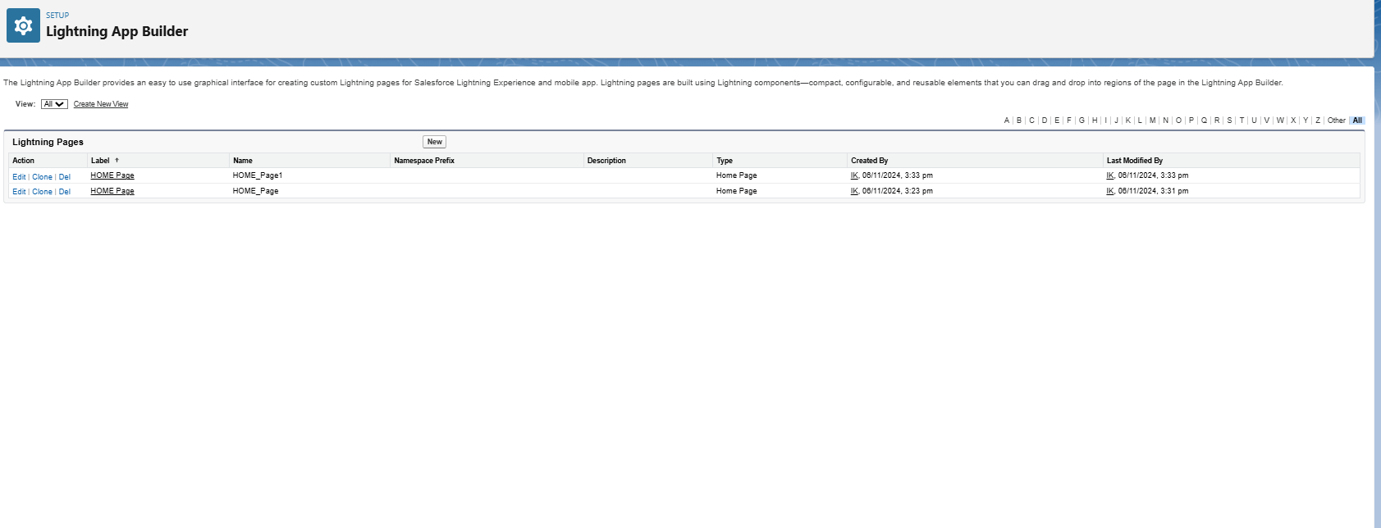

**Fields**

To structure your Salesforce app for a food distribution project, you need to create objects and define fields to capture and manage data effectively. Here’s a detailed guide on setting up fields, relationships, and creating key objects like **Venue**, **Drop-Off Point**, **Task**, **Volunteer**, and **Execution Details**.

**creating fields and relationship fields in object**

* **Standard Fields**: These are predefined by Salesforce, like "Name" and "Created Date."
* **Custom Fields**: Add fields to capture specific information for each object.
* **Relationship Fields**:
* **Lookup Relationship**: Links two objects loosely, allowing null values.
* **Master-Detail Relationship**: A tighter link where the child object depends on the parent, inheriting permissions and sharing settings.

**Creating Relationships**:

**In Setup**, go to the **Object Manager**.

* + Open the object where you want to add a relationship field.
  + Select **Fields & Relationships**, then **New**.

Choose the type of relationship field:

* + For **Lookup**, select another object to link.
  + For **Master-Detail**, select the parent object.
  + Set field visibility, add help text, and save.

**Creating key objects for fields**

**a. Venue Object**

* **Purpose**: To store locations where food is available for pickup.
* **Key Fields**:
  + **Venue Name** *(Text)*: Name of the venue.
  + **Address** *(Text Area)*: Detailed address of the venue.
  + **Contact Number** *(Phone)*: Venue’s contact information.
  + **Capacity** *(Number)*: Maximum amount of food that can be stored at this venue.
  + **Venue Type** *(Picklist)*: Options like "Restaurant," "Event Hall," or "Catering Service."
  + **Status** *(Picklist)*: Indicates availability (e.g., Available, Closed).
* **Relationships**:
  + **Related to Drop-Off** (Lookup or Master-Detail with Drop-Off Point): Shows available drop-off points for each venue.

**b. Drop-Off Point Object**

* **Purpose**: To track locations where food is delivered.
* **Key Fields**:
  + **Drop-Off Location Name** *(Text)*: Name of the drop-off point.
  + **Distance** *(Number)*: Distance from the venue to drop-off point.
  + **Address** *(Text Area)*: Detailed address.
  + **Operational Hours** *(Text)*: Hours during which drop-off is accessible.

* **Relationships**:
  + **Linked Venue** (Lookup or Master-Detail with Venue): Connects each drop-off point to a specific venue for reference.

**c. Task Object**

* **Purpose**: To track tasks associated with food collection and delivery.
* **Key Fields**:
  + **Task Name** *(Text)*: Brief name of the task.
  + **Description** *(Text Area)*: Details about the task.
  + **Assigned Volunteer** (Lookup with Volunteer): Assigns a volunteer to each task.
  + **Due Date** *(Date)*: When the task needs to be completed.
  + **Priority** *(Picklist)*: Options like High, Medium, Low.
* **Relationships**:
  + **Related Venue or Drop-Off** (Lookup): Links tasks to specific venues or drop-off points as needed.

**d. Volunteer Object**

* **Purpose**: To manage volunteer details.
* **Key Fields**:
  + **Volunteer Name** *(Text)*: Full name of the volunteer.
  + **Contact Information** *(Phone)*: Phone number of the volunteer.
  + **Email** *(Email)*: Volunteer’s email address.
  + **Availability** *(Picklist)*: Options like "Available," "Not Available," "Part-Time."
* **Relationships**:
  + **Assigned Tasks** (Master-Detail or Lookup with Task): Links volunteers to specific tasks.
  + **Associated Venues** (Lookup or Master-Detail with Venue): Allows linking volunteers to specific venues if needed.

**e. Execution Details Object**

* **Purpose**: To record details of each food delivery event.
* **Key Fields**:
  + **Execution Name** *(Text)*: Name of the execution event.
  + **Start Date** *(Date)*: Start date of the event.
  + **End Date** *(Date)*: Completion date.
  + **Total Food Distributed** *(Number)*: Quantity of food distributed.
  + **Volunteers Involved** *(Lookup with Volunteer)*: Record of volunteers who participated.
  + **Challenges Encountered** *(Text Area)*: Brief description of any issues faced.

**Relationships**:

* + **Venue and Drop-Off Link** (Lookup with Venue and Drop-Off): Links the execution details with specific venues and drop-off points.

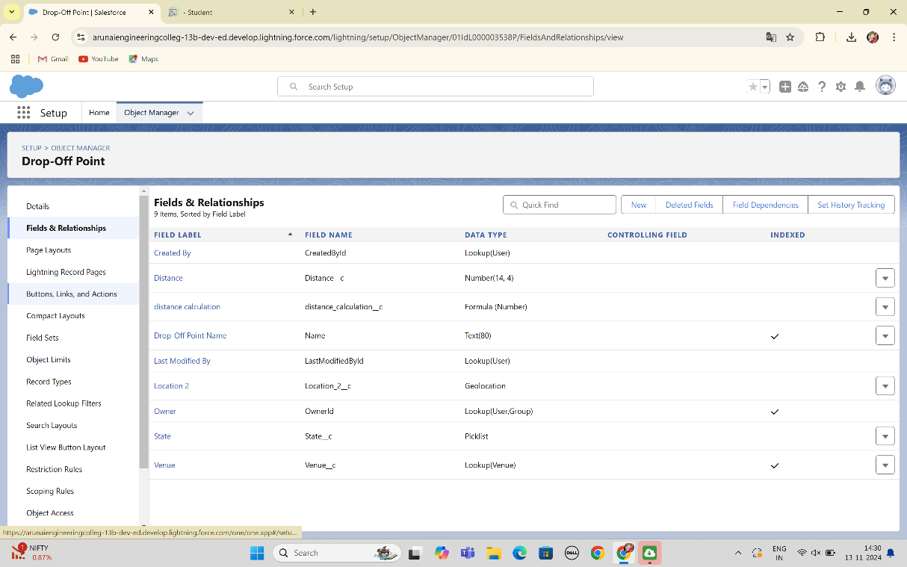

**Flows**

In Salesforce, **Flows** are powerful automation tools that can automate processes such as record creation, updates, notifications, and complex logic. Here’s an overview of creating flows, and then specifically, setting up a flow to create a record in the **Venue** object.

* **Screen Flows**: Used for guided user input; can be used on pages.
* **Record-Triggered Flows**: Automatically trigger on record creation, updates, or deletions.
* **Scheduled Flows**: Run on a set schedule to perform routine tasks.
* **Platform Event-Triggered Flows**: Triggered by platform events for real-time integration.

**Steps to Create a Flow to Add a Venue Record**

#### 1. Start a New Flow

* Go to **Setup** in Salesforce, type **Flows** in the Quick Find box, and select **Flows**.
* Click **New Flow**.
* For this task, select **Screen Flow** if you want user input for creating a Venue record or **Record-Triggered Flow** if it should automatically create Venue records under specific conditions.

#### 2. Configuring the Flow

* **Screen Flow Setup**:
  + **Step 1**: Drag a **Screen** element from the **Toolbox** on the left.
  + **Step 2**: On the screen, add fields that users will fill out, such as **Venue Name**, **Address**, **Contact Number**, **Capacity**, and any other relevant fields.
  + **Step 3**: Set component types to match field data (e.g., Text, Phone, Number, Picklist).
* **Record-Triggered Flow Setup**:
  + **Step 1**: In **Trigger the Flow When**, select **A record is created**.
  + **Step 2**: Choose the object and specify any criteria that should trigger the record creation.

#### 3. Adding the Create Record Element

* Click **+ Add Element** in the flow canvas and select **Create Records**.
* **Label** the action, for example, "Create Venue Record."
* **Select the Venue Object**: Choose **Venue** as the object where the record will be created.

#### 4. Define the Field Values

* Map the fields in the **Venue** object to the corresponding input fields or variables:
  + **Venue Name**: Map to the name input provided by the user or predefined value.
  + **Address**: Link to a text input field.
  + **Contact Number**: Map to the phone input field.
  + **Capacity**: Map to the number input field.
* **Choose Fields and Set Values**: Ensure that required fields are mapped.

#### 5. Save and Activate the Flow

* Click **Done** to save the element setup.
* **Save the Flow** with a descriptive name, such as "Create Venue Record Flow."
* Activate the flow by clicking **Activate** in the Flow Builder toolbar.

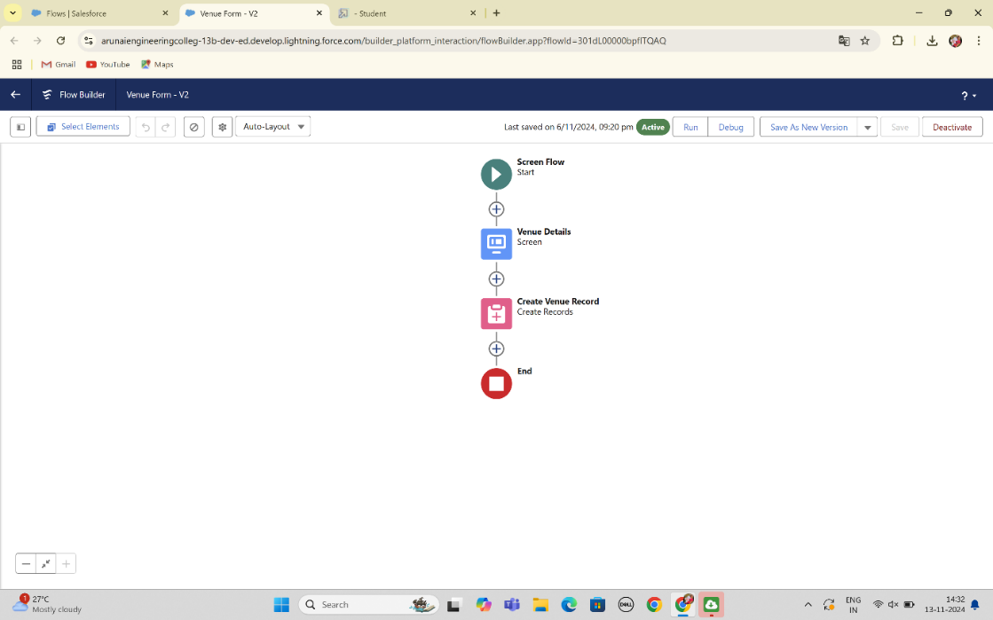

**Testing And Validation**

**Trigger**

To create a **trigger** in Salesforce that automatically creates a record in the **Venue** object based on a specific condition or event, you'll need to write an **Apex Trigger**. Here’s a step-by-step guide, along with an example trigger.

**Steps to Create a Trigger in Salesforce**

1. **Access Developer Console**:
   * In Salesforce, click the **Gear Icon** (⚙️) and select **Developer Console**.
2. **Create a New Trigger**:
   * In the Developer Console, go to **File** > **New** > **Apex Trigger**.
   * Choose the object you want the trigger to be associated with. For instance, if you want the trigger to create a **Venue** record when a **Task** record is created, select the **Task** object.
   * Name the trigger (e.g., CreateVenueOnTaskTrigger).
3. **Define the Trigger Logic**:
   * Define when the trigger should fire, such as **before insert** or **after insert**.
   * Specify the actions the trigger will take, such as creating a new **Venue** record.

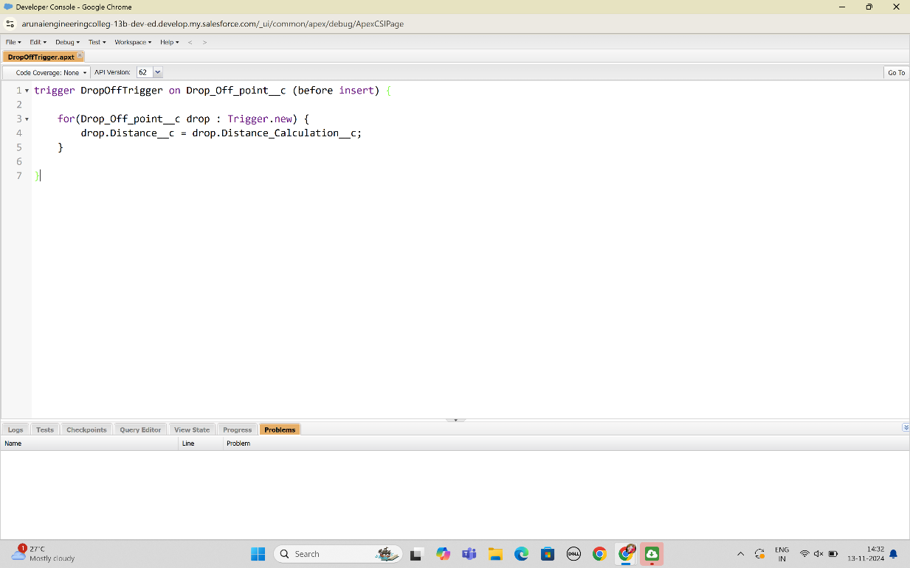

**Profiles**

In Salesforce, **Profiles** are crucial for controlling user access to data, objects, and specific features within your app. Profiles define user permissions, such as object permissions, field-level security, app settings, and more. Here’s a guide to creating and configuring profiles for your project.

1. **Standard Profiles**: Predefined by Salesforce with fixed permissions (e.g., System Administrator, Standard User).
2. **Custom Profiles**: Created to provide specific permissions tailored to the needs of your project. Custom profiles allow you to control access at a more granular level.

**Steps to Create and Configure Profiles in Salesforce**

#### 1. Accessing Profiles

* In **Setup**, type **Profiles** in the Quick Find box and select **Profiles**.
* You will see a list of existing profiles, including both standard and custom profiles.

#### 2. Creating a New Profile

* To create a custom profile, you can either clone an existing profile or start from scratch.
* **Clone a Profile**:
  + Select a standard profile (like "Standard User") that closely matches the permissions you need.
  + Click **Clone** to create a new profile based on this existing profile.

#### 3. Configuring Profile Settings

* **Profile Name**: Name your profile, e.g., "Venue Manager" or "Volunteer Coordinator".
* **Object Permissions**:
  + Scroll down to **Custom Object Permissions**.
  + For each custom object (e.g., **Venue**, **Drop-Off Point**, **Task**, **Volunteer**, **Execution Details**), set the appropriate permissions:
    - **Read**: Allows viewing records.
    - **Create**: Allows creating new records.
    - **Edit**: Allows editing existing records.
    - **Delete**: Allows deleting records.
  + For example, a "Venue Manager" profile might have full access to the **Venue** object but limited access to other objects.
* **Field-Level Security**:
  + Go to each custom object and specify **Field-Level Security** for each field.
  + Set fields to **Read-Only** or **Hidden** if certain data should not be edited or viewed by this profile.
* **Tab Settings**:
  + Under **Tab Settings**, control which tabs users with this profile can see.
  + Set each tab (e.g., **Venue**, **Task**) to **Default On**, **Default Off**, or **Hidden**.
* **App Settings**:
  + Assign this profile to specific apps, such as the **Food Connect** app you created.
  + Under **Assigned Apps**, select the apps that should be visible to users with this profile.
* **Page Layout Assignment**:
  + For each object, assign a **Page Layout** to control how information is displayed to users.
  + For instance, for the **Venue** object, a manager might see more detailed layouts, while volunteers see a simpler version.

#### 4. Assigning Profiles to Users

* After setting up a profile, assign it to users.
* Go to **Setup > Users**, find the user, and edit their profile to assign the new custom profile

**Creation of Users**

1. Go to setup page >> type users in Quick Find bar >> click on users>> New user.
2. In General Information give details as: (Note : create users as per your wish NGO’s)

First Name : Iksha Foundation

Last Name : Iksha_Foundation

Alias : iiksh

Email : Give Your Email

Username : [ikshafoundation@sb.com](mailto:ikshafoundation@sb.com) (give the username different)

Nickname : Auto Populated

User License : Salesforce Platform

Profile : NGOs Profile

Active : Check

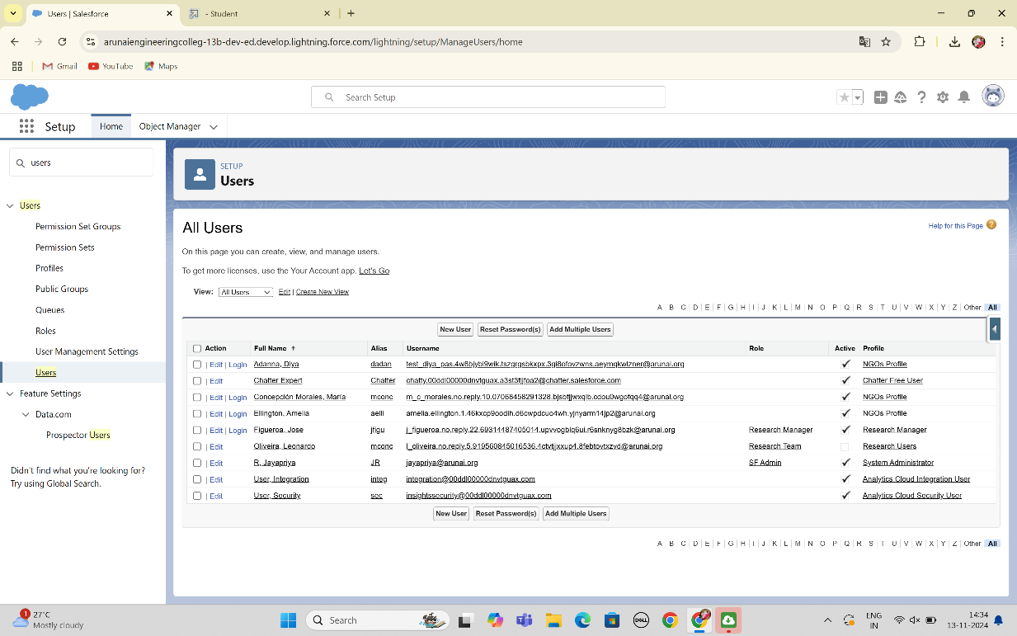

**Creation of public group1&2**

1. Go to setup page  >>  type Public Groups in Quick Find bar  >>  click on Public Groups >>  click on New.
2. Under Group Information:
   1. Label : Iksha
   2. Group Name : Iksha
   3. Grant Access Using Hierarchies : Check
3. In Search, Select Users.
4. In Selected Members Add Iksha Foundation and System Administrator
5. By Following Steps in Activity 1, Create other  two Public Groups for other two users.
6. After Saving this would look like this.

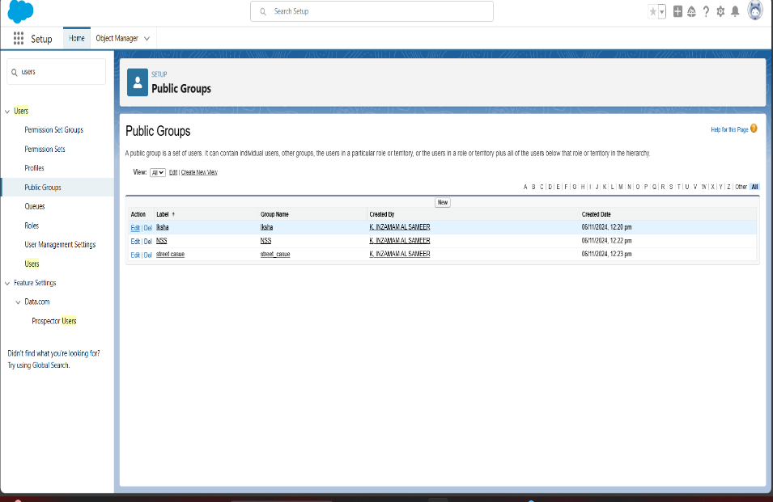

**Report types**

In Salesforce, **Report Types** define the set of data and relationships that reports can access. By customizing report types, you can tailor them to fit your project needs, such as tracking venue usage, volunteer participation, or task completion for your food distribution project.

**Standard Report Types**:

* Automatically created for standard and custom objects where "Allow Reports" is enabled.
* They include standard fields and relationships, such as Venue, Task, and Volunteer if these are set to "Allow Reports" in your objects.
* Useful for basic reports, but they might lack specific fields or relationships needed for complex reporting.

**Custom Report Types**:

* Allow customization of relationships between objects and selection of specific fields.
* Enable you to create reports that include records from multiple related objects (e.g., Venue with related Drop-Off Points, or Tasks assigned to specific Volunteers).
* Allow you to specify a primary object and add related objects up to three levels deep.

**Creation of report types**

1. Go to setup page  >>  type Report Types in Quick Find bar  >> click on Report Types  >>  click on Continue   >>  Click on New Custom Report Type.
2. In Define the Custom Report Type:
   1. Primary Object : Select Venues
   2. Report Type Label : Venue with Drop Off with Volunteer
   3. Report Type Name : Venue_with_Drop Off_with_Volunteer
   4. Description : Venue with Drop Off with Volunteer
   5. Store in Category : Select Other Reports
   6. Deployment Status : Deployed
3. Click on Next
4. Near Click to relate another Object Select Drop-Off Points.
5. And also select "A" records may or may not have related "B" records.
6. Now again Near Click to relate another Object Select Volunteers.
7. Now click on Save.

### **I.Creation of Report on Venue with Drop Off with Volunteer**

1. Go to the app(Food Connect)  >>  click on the reports tab
2. Click on New Folder.

Folder Label : Custom Reports

Folder Unique Name : Custom Reports

1. Open Custom Reports and click on New Report
2. Select Report Type : Venue with Drop Off with Volunteer
3. Then click on Start Report.
4. In GROUP ROWS : Add Volunteer Name
5. In Columns : Add Venue Name, Drop-Off point Name, Distance.
6. Now click on Save & Run.
7. Give Label as :
8. Report Name : venue and Drop Off point
9. Report Unique Name : Auto Populated
10. Click on Select Folder and select Custom Report, then click on Save.

### **II.Creation of Report on Volunteers with Execution Details and Tasks**

1. Go to the app(Food Connect)  >>  click on the reports tab
2. Click on Custom Reports Folder and click on New Report
3. Select Report Type : Volunteers with Execution Details and Tasks.
4. Then click on Start Report.
5. In GROUP ROWS : Volunteer ID
6. In Columns : Add Volunteer : Volunteer Name, Task : Task Name, Execution Detail : Execution Detail Name, Volunteer: Owner Name, Task: Date, Task : Rating.
7. Now click on Save & Run.
8. Give Label as :

Report Name : Volunteer Task

Report Unique Name : Auto Populated

Click on Select Folder and select Custom Report, then click on Save

**After Creation Of Report I&Ii**

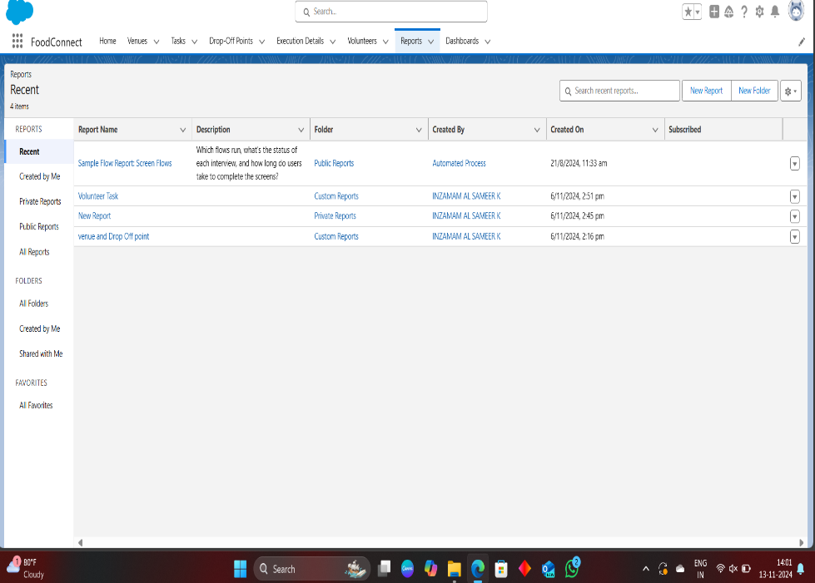

**Dashboard**

In Salesforce, **Dashboards** are visual representations of data collected from reports, allowing users to monitor key metrics and gain insights at a glance. Dashboards are built using **components** (e.g., charts, tables, metrics), each representing a report. For your food distribution project, a dashboard could track metrics like the number of active venues, tasks completed by volunteers, and food distributed.

**Steps to Create a Dashboard in Salesforce**

1. **Access Dashboards**:
   * Go to the **Dashboards** tab in Salesforce.
   * Click **New Dashboard** to create a new dashboard.
2. **Set Dashboard Properties**:
   * **Name**: Enter a name, such as "Food Distribution Overview."
   * **Description**: Provide a brief description of what the dashboard tracks, e.g., "Tracks venues, volunteer tasks, and distribution statistics."
   * **Folder**: Select a folder to save the dashboard. This controls visibility for other users.
   * **View As**: Set who should be the running user for the dashboard. This setting defines whose data permissions are applied when viewing the dashboard.
3. **Add Dashboard Components**:
   * Click **+ Component** to add a report component to the dashboard.
   * Choose a report to use (only saved reports can be added).
   * Select a **Component Type** (e.g., bar chart, pie chart, table) that best represents the data.
   * Customize the component’s settings, including title, display units, and colors.
   * **Repeat** this process to add multiple components, one for each report or metric you want to track.
4. **Arrange and Customize Components**:
   * **Resize and Reposition**: Drag components to rearrange and resize them for better visual flow.
   * **Component Details**: Edit each component’s title and subtitle to ensure they’re descriptive (e.g., “Tasks Completed by Volunteers” or “Food Distributed by Venue”).
   * **Apply Filters**: Set global filters for the dashboard, such as filtering by time period or specific locations, which will apply to all components.
5. **Save and View Dashboard**:
   * Click **Save** to save your progress.

### **I.Adding venue and Drop Off point Report to the Dashboard**

1. Go to the app(Food Connect)  >>  click on the Dashboards tab.
2. Click on New Folder.

Folder Label : Custom Dashboards

Folder Unique Name : Auto Populated

1. Open Custom Dashboards and click on New Dashboards
2. Name : Organization Details
3. Click on Widget and select Chart or Table
4. In Select Report : Select venue and Drop Off point Report.
5. Then click on select
6. In Add Component:

Display As : Select Lightning Table

Component Theme : Select Dark (Optional)

Now click on save.

### **II.Adding Volunteer Task Report to the Dashboard**

1. Click on Widget and select Chart or Table
2. In Select Report : Select Volunteer Task Report.
3. Then click on select
4. In Add Component:

Display As : Select Line Chart

Component Theme : Select Dark (Optional)

### **III.Adding a Picture to the Dashboard**

1. Click on Widget and select Image. Then click on Browse Files.
2. Then Select the Picture you want to upload in this Dashboard.
3. Then click on Save As :
   1. Name : Task Execution Details
   2. Click on Select Folder and select Custom Dashboards
4. Click on Select Folder and then Save.

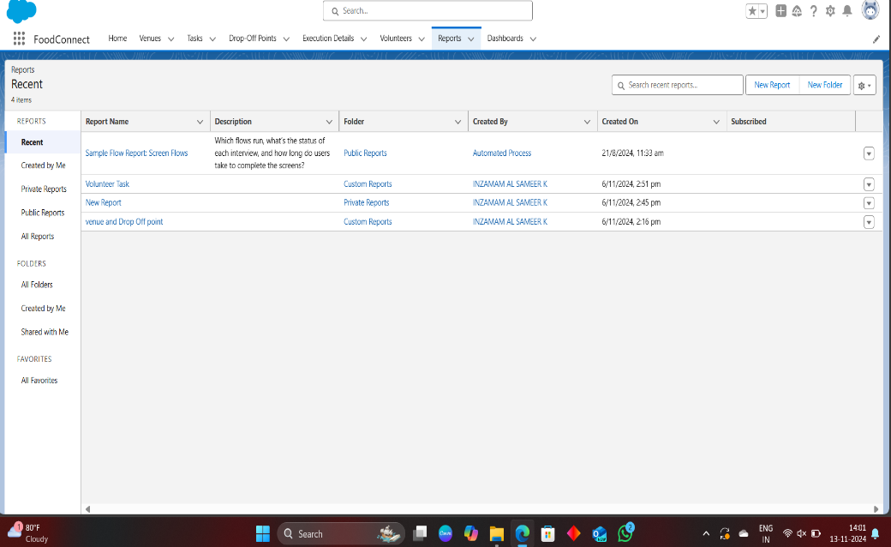

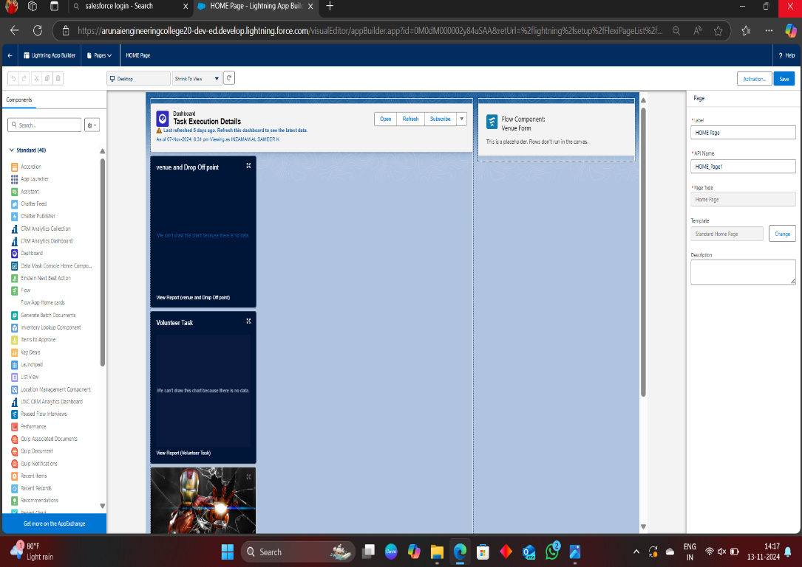

**Sharing rules**

**Sharing Rules** in Salesforce are used to extend data access to users based on specific criteria, overriding the default **Organization-Wide Defaults (OWD)**. Sharing rules allow you to share records with particular users, roles, or groups based on either ownership or field-based criteria. For your food distribution project, sharing rules can help control access to objects like **Venue**, **Task**, **Volunteer**, and **Execution Details**, ensuring data is visible to the right people without compromising security.

**Creation of sharing rules**

1. Go to setup  >>  type Sharing Settings in quick find box  >>  Click on the Sharing Settings.
2. Scroll down and find Drop-Off point Sharing Rules.
3. Click on new near Drop-Off point Sharing Rules and Name it as:
   * 1. Label : Rule 1
     2. Rule Name : Rule_1
4. Select your rule type : Select Based on criteria.
5. Select which records to be shared:
   * 1. Field : Operator : Value = Distance : less than : 15
6. Select the users to share with : Near Share With
   * 1. Public Groups : Iksha
7. Click on Save.
8. Click on new near Drop-Off point Sharing Rules and Name it as:
   * 1. Label : Rule 2
     2. Rule Name : Rule_2
9. Select your rule type : Select Based on criteria.
10. Select which records to be shared:
11. Field : Operator : Value = Distance : greater than : 15
12. Field : Operator : Value = Distance : less or equal : 30
13. Select the users to share with : Near Share With
    * 1. Public Groups : NSS
14. Click on Save.
15. Click on new near Drop-Off point Sharing Rules and Name it as:
    * 1. Label : Rule 3
      2. Rule Name : Rule_3
16. Select your rule type : Select Based on criteria.
17. Select which records to be shared:
    * 1. Field : Operator : Value = Distance : greater than : 30
      2. Field : Operator : Value = Distance : less or equal : 50
18. Select the users to share with : Near Share With
    * 1. Public Groups : Street Cause
19. Click on Save.

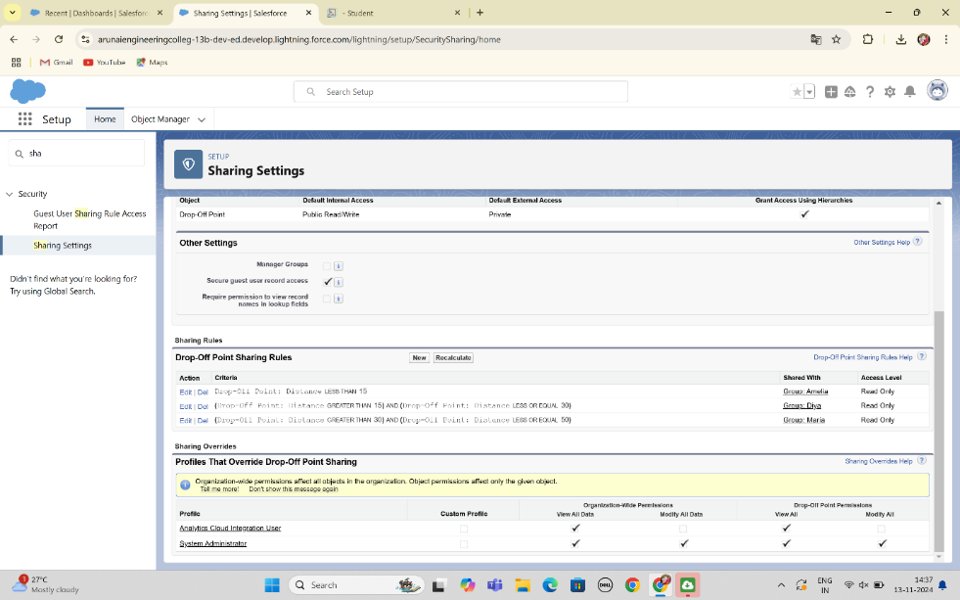

**Homepage**

Creating a **Home Page** in Salesforce allows you to design a personalized landing page that displays key metrics, quick links, and other components users need when they first log in. For your food distribution project, a custom Home Page can include components like recent venues, task updates, and volunteer assignments to streamline navigation and increase efficiency.

### **Creation of Home Page**

1. Go to setup >> type Lightning App Builder in quick find box  >>  Click on the Lightning App Builder and Select the New.
2. Select Home Page and give Label as HOME Page.
3. Select Standard Home Page.
4. Near Components search for Flow and Drag and Drop in Right Side Section..
5. On the right hand side:

Flow : Venue Flow

1. Near Components search for Dashboard, then Drag and Drop it in first Section
2. Click on Save and Activation, then click on App Default, then Add Assignments.
3. Add Food Connect App and then Save.
4. Food Connect Home Page would Look Like this.

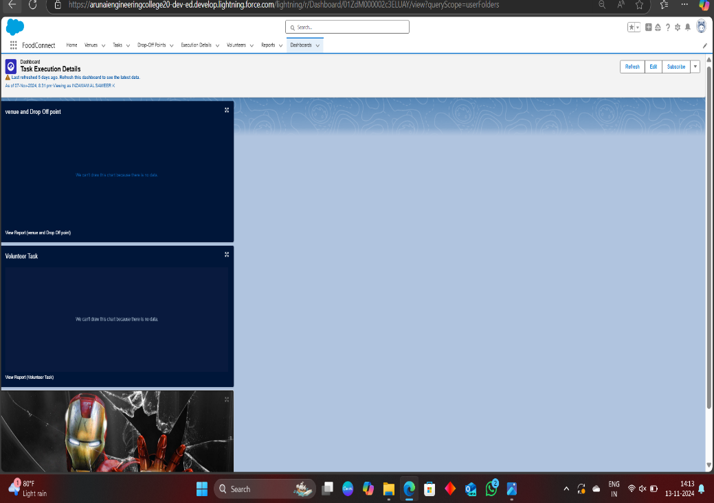

**Key Scenarios Addressed by Salesforce in the Implementation Project**

In the **Food Distribution Project** implemented in Salesforce, key scenarios are addressed through customized objects, automation, and access controls, creating an efficient and streamlined process for managing food collection and distribution. Below are the primary scenarios that Salesforce addresses in this project

### 1. **Managing Food Collection Locations (Venues)**

* **Scenario**: Track locations where leftover food is collected, including restaurants, event halls, and catering services.
* **Solution**: Salesforce’s **Venue** object is customized to store details like venue name, address, contact information, and storage capacity. This data helps project managers organize and manage food pickup from various locations.
* **Automation**: A **record-triggered flow** automatically creates initial tasks when a new venue is added, assigning pickup duties to volunteers or coordinators.

### 2. **Coordinating Food Distribution to Drop-Off Points**

* **Scenario**: Ensure food collected from venues is delivered to designated drop-off points where it can reach those in need.
* **Solution**: The **Drop-Off Point** object in Salesforce captures drop-off location information, including address and operational hours, ensuring each location’s details are organized and accessible.
* **Reporting**: A custom report tracks distribution quantities and utilization at each drop-off point, enabling better planning and resource allocation.

### 3. **Volunteer Management and Task Assignment**

* **Scenario**: Assign tasks to volunteers for food collection and distribution while tracking their availability and participation.
* **Solution**: The **Volunteer** and **Task** objects work together to manage assignments, with fields for volunteer contact info, availability status, and assigned tasks.
* **Automation**: Apex triggers or flows assign tasks based on criteria like availability or proximity to the venue. Volunteers receive notifications about new tasks and can update their status upon task completion.
* **Dashboard**: A dashboard component displays task completion rates, allowing project managers to monitor volunteer activity and task progress.

### 4. **Tracking Distribution Events and Execution Details**

* **Scenario**: Document details of each food distribution event, including total food distributed, challenges encountered, and volunteers involved.
* **Solution**: The **Execution Details** object captures event-specific information such as start and end dates, quantities distributed, and any issues that arose during distribution. This enables better tracking and reporting for each distribution effort.
* **Reporting**: Reports are generated to analyse the performance of each distribution event, including volunteer contributions and recurring challenges, helping to improve future operations.

### 5. **Data Access and Security through Profiles and Sharing Rules**

* **Scenario**: Restrict data access based on user roles, ensuring volunteers, managers, and coordinators see only the data relevant to their roles.
* **Solution**: Custom profiles (e.g., **Volunteer**, **Venue Manager**) and sharing rules ensure that only authorized users can view or edit specific objects. For example, volunteers have access to their assigned tasks but not venue or execution details.
* **Sharing Rules**: Criteria-based sharing rules allow additional access where necessary, such as allowing high-priority tasks to be visible to managers.

### 6. **Real-Time Reporting and Data Visualization**

* **Scenario**: Provide project managers with insights into food distribution metrics, venue usage, task completion, and volunteer activity.
* **Solution**: Salesforce reports and dashboards display metrics like active venues, total food distributed, task completion rates, and volunteer engagement. These insights allow for data-driven decision-making, enabling efficient management of the distribution process.
* **Example Reports**:
  + **Venue and Drop-Off Utilization**: Tracks which locations are most active in food collection and distribution.
  + **Volunteer Activity**: Monitors task completion rates for volunteers and identifies top contributors.

### 7. **User-Friendly Navigation and Custom Home Page**

* **Scenario**: Enable quick access to key features, updates, and metrics for each user role, enhancing usability and efficiency.
* **Solution**: A custom **Home Page** with components like recent items, dashboard highlights, and quick links provides a personalized landing page. Users can access recent tasks, view key metrics, and navigate quickly to objects like Venue and Task.
* **Benefits**: This setup saves time for end-users by centralizing essential information and making the interface intuitive and navigable.

**Conclusion**

The **Food Distribution Project** in Salesforce optimizes the process of collecting and distributing leftover food to those in need. By using Salesforce objects for **Venue**, **Drop-Off Point**, **Task**, **Volunteer**, and **Execution Details**, the project enables efficient tracking of food collection sites, distribution locations, and volunteer assignments. Automation through flows and triggers reduces manual tasks, while custom profiles and sharing rules ensure data security, allowing users to access only the information relevant to their roles.

Real-time **dashboards** and **reports** provide valuable insights into distribution metrics, volunteer activity, and task progress, supporting data-driven decisions and resource allocation. A customized **Home Page** streamlines navigation by displaying recent activity, key metrics, and quick links. Overall, Salesforce empowers the project with enhanced organization, accountability, and scalability, making it an effective tool for addressing food distribution challenges and supporting communities in need.